**Drink Dispenser**

1. **Description:**

A drink dispenser is a machine that provides drinks to the consumers after a selection is made. For the project we have selection of four drinks of color Blue, Magenta, Red and Green. An indicator is shown above every dispenser which is changed from Red to Green if the drink must be dispensed.

1. **Example:**

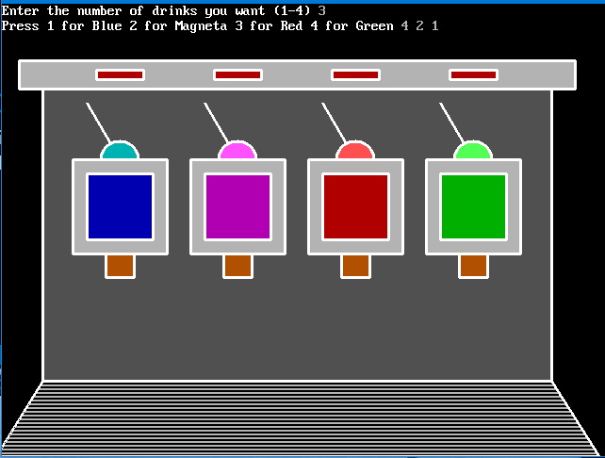 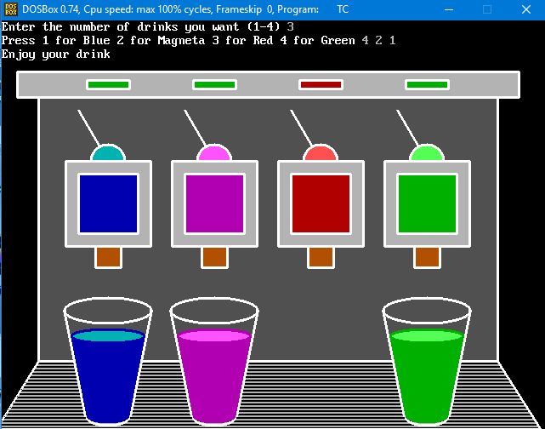

Figure (i) Figure (ii)

Figure (i): In the example we chose to have 3 drinks. We were then asked to select the color of the drinks we require. The input given was 4, 2, 1. The input is then sorted to get sequence 1, 2, 4.

Figure (ii): For the given set of inputs only 3 glasses appear below the Blue, Magenta and Green drink. We can also note that as the Red drink is not supposed to be filled there is no glass under it and the indicator is still Red. A message “Enjoy your drink” is received after all the glasses are filled.